

Maryland Horse Shows Association
Creating Horse Show Traditions Since 1932
Elizabeth Solter Emerging Athlete Award
2022 APPLICATION
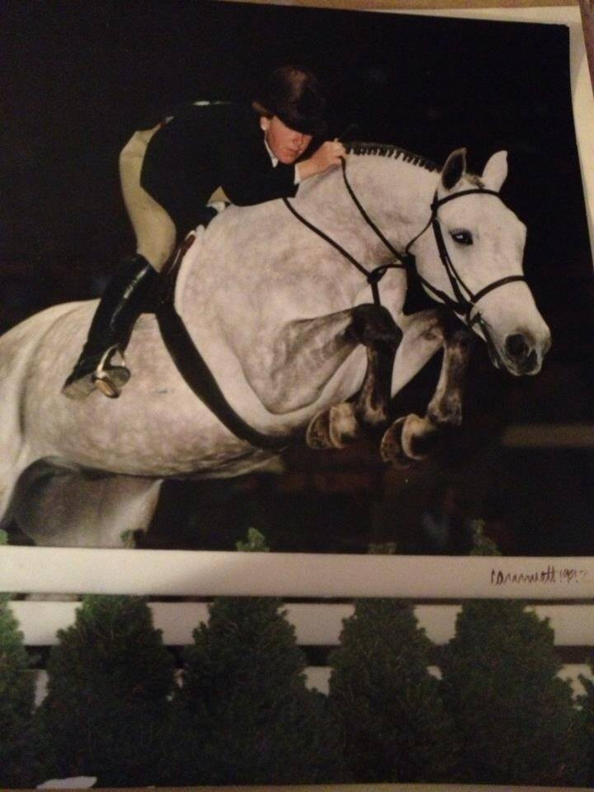
Award overview:
- The Elizabeth Solter Emerging Athlete Award is awarded to a dedicated and knowledgeable young rider (USEF horse show age 15-30) who has demonstrated the enthusiasm, work ethic and aptitude necessary for success as a horseman
- The award winner would have the talent and ambition to excel in the hunter/jumper industry; and must be capable of riding in the hunter, equitation and jumper rings
- Exemplary all-around performance: from riding to horsemanship to sportsmanship will be reviewed
- The award winner will be someone who has a future as a rider in the sport, as well as a successful horseman who is viewed as a "good sport" among his/her peers
- Must be a current member of MHSA and in good standing
- $1,000 cash bonus to be included to use as a scholarship for college, or in the case of a young professional, to go towards horse business-related expenses
- Applications to be accepted from the MHSA general membership. An application can be filled out as a nomination by someone else, on behalf of a MHSA member. The winner will be chosen by a 3-person committee appointed by the President. The award will be given at the annual MHSA Awards Banquet.
- Attached form and essay questions must be submitted to the MHSA office via scan/email (secretary@mdhsa.org) or via mail – MHSA (Solter Award), PO Box 127 Hampstead, MD 21074 – by October 1, 2022.

HANDWRITTEN APPLICATIONS WILL NOT BE ACCEPTED.
Name_______________________________________________________________
Address______________________________________________________________
City/State/Zip_________________________________________________________
Birthdate_____/_____/_____MHSA#________________ USEF#_________________
Year in high school/college – or highest level of education completed____________
____________________________________________________________________
Are you completing this application on behalf of yourself? Yes_________ N0_________
If “NO”, name of person doing the nominating: _________________________________

For the following questions, feel free to attach a separate page if extra room is needed.
- Please list your top 3 riding accomplishments:
_____________________________________________________________________
_____________________________________________________________________
_____________________________________________________________________
_____________________________________________________________________
- Please name 3 of your biggest riding influences - with a one sentence description about the traits or values that made you select that individual:
_____________________________________________________________________
_____________________________________________________________________
_____________________________________________________________________
_____________________________________________________________________
_____________________________________________________________________
_____________________________________________________________________
- Please provide an example of how your work ethic has helped you with riding and showing:
_____________________________________________________________________
_____________________________________________________________________
_____________________________________________________________________
_____________________________________________________________________

- Give an example of a horse that has been a puzzle and how did you solve it?_____________________________________________________________
_____________________________________________________________________
_____________________________________________________________________
_____________________________________________________________________

- What are your future goals in the horse industry?
_____________________________________________________________________
_____________________________________________________________________
_____________________________________________________________________
_____________________________________________________________________

- Why do you deserve the 2022 Elizabeth Solter Emerging Athlete Award?
_____________________________________________________________________
_____________________________________________________________________
_____________________________________________________________________
_____________________________________________________________________
_____________________________________________________________________

